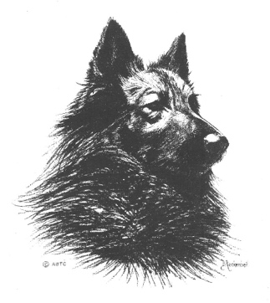
American Belgian Tervuren Club
Application for a Breeder Achievement Record (BAR) Plaque
BAR Plaques are made once a year for the ABTC Annual Awards Banquet held with the National Specialty.

- Plaques awarded are for BARs earned during the previous year. Titles earned by offspring and grand offspring between December 31 and the National Specialty/Awards Banquet will not be included for plaque creation or published lists for recognition at the Awards Banquet in the same year the title was earned.
- Points earned between year end and the ABTC Awards banquet are credited to the recipient and the BAR plaque is created for the subsequent ABTC Awards Banquet. No exceptions.

Name of owner(s) - I am a member in good standing of the American Belgian Tervuren Club – check here:

_____________________________________________________________________
(This information will be included on the plaque)

Owner email: _________________________________________________________
Owner address:

_____________________________________________________________________
Street City

_____________________________________________________________________
State Zip Phone

Name of dog (include only AKC/ABTC titles):

_______________________________________________________________________
(This information will be included on the plaque.)

Applying for:

Conformation BAR plaque Obedience BAR Plaque Performance BAR Plaque

I am applying for a BAR Pin. My Tervuren has earned two or more ABTC BAR awards.
Pins are limited to one per person; I have not previously been awarded a BAR Pin.

I will be attending the Awards Banquet and request Banquet presentation. Check here:
Plaques will be mailed to recipients not attending the annual awards banquet.

Return this form and required documentation by February 29, 2024 to:
Katherine Shogren, Awards Chair, 4708 Misty SQ, Colorado Springs, CO 80918
email: kshogren@yahoo.com

Electronic submission of forms and documentation sufficient to substantiate award as defined in the BAR Standard is acceptable (progeny report/ABTC Bar Inquiry webpage print).

